PART 1 – GENERAL
  - DESCRIPTION
- DURASHIELD Pavement Coatings are specifically formulated for application to asphalt pavement and have been confirmed by a certified testing facility to possess a balance of performance properties for a durable and color-fast finish.
- Qualifications. Only Certified StreetBond® Applicators Certified for SB90/DURASHIELD may bid for and perform this work and issue warranties backed by GAF - StreetBond. Please refer to Section 1.3 DEFINITIONS.
- Products are manufactured in ISO 9001:2015 facilities to ensure quality products produced in legally-responsible and environmentally conscious manner.
- DURASHIELD is only available from GAF - StreetBond or its affiliates.

  - REFERENCES
- ASTM D4541 | Standard Test Method for Pull-Off Strength of Coatings Using Portable Adhesion Tester.
- ASTM D4060 | Test Method for Abrasion Resistance of Organic Coatings by the Taber Abraser.
- ASTM D2697 | Standard Test Method for Volume of Nonvolatile Matter in Clear or Pigmented Coatings.
- ASTM D522-93A | Standard Test Method for Mandrel Bend Test of Attached Organic Coatings.
- ASTM D1653 | Standard Test Method for water vapor transmission through organic film coatings.
- ASTM D2369 | Weight Solids Standard test method for Volatile Content  of Coatings.
- ASTM D1475 | Standard Test Method for Density of Paint, Varnish, Lacquer, Other related products
- ASTM D2240 (2000) | Standard Test Method for Rubber property –  Durometer hardness.
- ASTM D5895 | Standard Test Method of drying or curing during film formation of organic coatings using mechanical recorders.
- ASTM D570 | Standard Test Method for water absorption of plastics.

  - DEFINITIONS

- “Certified StreetBond® Applicator” has valid Certification for SB90/DURASHIELD as offered by StreetBond and reviewed on a bi-annual basis. All Certified StreetBond® Applicators with appropriate Certification have been qualified by StreetBond to perform the Work and offer a product Warranty.
- “Owner” means the property owner and/or the representative who has decision making authority for the work on the property.
- “Work” is the application of DURASHIELD performed by an Authorized Applicator per specifications.
- “Scuffing” is a tear of the asphalt pavement caused by an external force – for example turning the steering wheel of a stationary vehicle. Scuffing is generally the result of poorly designed or improperly installed asphalt and would most - commonly be seen on weaker residential asphalt.
- “Layer” is a single pass of coating, which is allowed to dry before a subsequent layer is applied.
- “Warranty” is a guarantee to the property owner that the product will perform to minimum requirements for a period of xxx (x) years when installed by an Authorized Applicator per specifications outlined in the Coating Plan.
- “Coating Plan” is a job specific plan showing the amount of layers of the coating to be installed in given zones of the project.
- “Submittal Package” is provided as part of the bid which lists the products used and specifications.
- “Pavement Coating FSR” is the Field Services Representative specializing in pavement coatings and representing GAF - StreetBond or its affiliate in a given territory.

  - SUBMITTALS
The applicator must be authorized by the manufacturer to install DURASHIELD and issue warranties. Submittal Packages shall include a copy of the Authorized Applicator Certificate (or Letter of Authorization) from the manufacturer. Independent product test results are available upon request.

  - WARRANTY
A Warranty may be provided when DURASHIELD is installed per manufacturer specifications by a Certified StreetBond® Applicator. Contact GAF - StreetBond Customer Success representative or the Pavement Coatings FSR for details.

PART 2 – PRODUCTS
2.1 MATERIALS - COATINGS
DURASHIELD has been scientifically formulated to provide the optimal balance of performance properties for a durable, long - lasting color and textured finish to asphalt pavement surfaces. Some of these key properties include wear and crack resistance, color retention, adhesion, minimal water absorption, and increased friction properties. DURASHIELD is environmentally safe and meet EPA requirements for Volatile Organic Compounds (VOC).
- DURASHIELD is a premium two-part, epoxy-modified waterborne acrylic coating specifically designed for application on asphalt pavements and is supplied pre-colored with silica aggregates blended at the factory for consistent, reliable product quality. It has a balance of properties to ensure good adhesion and movement on flexible pavement, while providing good durability. DURASHIELD is durable in both dry and wet environments.

2.1.1 Properties of Coatings
The following tables outline the test results for physical and performance properties of DURASHIELD as determined by an independent testing laboratory.

TABLE 1: Typical Physical Properties of DuraShield Pavement Coatings
Characteristic | Test Specification | DURASHIELD
Solids by Volume | ASTM D2697 | 57% +/- 2%
Solids by Weight | ASTM D2369 | 75% +/- 2%

TABLE 2: Typical Performance Properties of DuraShield Pavement Coatings
Characteristic | Test Specification | DURASHIELD
Dry time  (To re-coat) | ASTM D5895  23°C; 37% RH | 30 - 45 min
Taber Wear Abrasion Dry  H-10 wheel | ASTM D4060  1 day cure | <0.7 g/1000 cycles
Taber Wear Abrasion Wet  H-10 wheel | ASTM D4060  7 days cure | <3.0 g/1000 cycles
Hydrophobicity  Water Absorption | ASTM D570 | <8%
Mandrel Bend | ASTM D522 - 93A | 1-1/2” @ 23 C
VOC | per MSDS | <50 g/l
Adhesion | ASTM D4541 | >1000psi
Friction  Wet | ASTM E303  British Pendulum Tester | Wet>35  Dry>65  NB Friction is affected by the  texture of the substrate.
Solar Reflectance (Solar Gray color) | ASTM E903?  (spectrophotometer)  ASTM C1549?  (portable spectrophotometer)  ASTM E1918?  (Pyranometer) | >0.33 (initial)
Certificates of Analysis are available upon request for each of these properties.

2.2 EQUIPMENT FOR APPLICATION
The equipment described has been designed specifically for optimal application of DURASHIELD Pavement Coatings. Sprayers must be capable of applying textured coatings containing larger aggregate. Other equipment may or may not be suitable and could compromise the performance of the coatings and/or reduce crew productivity.
- The SB Flex Sprayer, Graco RTX, RapidSprayer II or equivalent texture sprayers that are capable of spraying the textured DURASHIELD shall be used. In addition, truck- or trailer-mounted spray bar equipment with sufficient capacity and pressure can be used for larger applications.
- For applying StreetBond Adhesion Promoter or StreetBond Sealer, a Backpack or Handheld “Garden” sprayer may be used.

PART 3 – EXECUTION
3.1 GENERAL
DURASHIELD shall be supplied and applied by an Certified StreetBond® Applicator with appropriate certification in accordance with the plans and specifications or as directed by the Owner. Do not begin installation without confirmation of the appropriate Accreditation Certificate. Specifications for the execution of the StreetPrint® system can be found at streetbond.com.

3.2 PRE-CONDITIONS
The condition of the asphalt substrate will impact the performance of the coating. A highly stable asphalt pavement free of defects is recommended.

3.2.1 Prerequisites for New Asphalt Pavement
A durable and stable asphalt pavement mix design installed according to best practices over a properly prepared and stable substrate is a pre - requisite for all long - lasting asphalt pavement surfaces. The application of the coatings does not change this requirement.

3.2.2 Pavement Marking Removal: recommended guidelines
Pavement markings may be removed by sand-blasting, water-blasting, grinding, or other approved mechanical methods. The removal methods should, to the fullest extent possible, cause no significant damage to the pavement surface.
The Owner shall determine if the removal of the markings is satisfactory for the application of the coating. Work shall not proceed until this approval is granted.

3.2.3 Surface Preparation

The asphalt pavement surface shall be dry and free from all foreign matter, including but not limited to dirt, dust, oil stains, de-icing materials, and chemical residue.

Where DURASHIELD is being applied to a surface that previously had sealcoat applied and there are areas that have significant sealcoat remaining, it may be necessary to treat the surface by first pressure washing with a 12“ fan and, while the surface is still wet, removing loose material using a rotary broom with aggressive bristles. The surface should then be allowed to dry thoroughly, (likely 24 to 48 hours).

StreetBond Adhesion Promoter should be applied to areas with exposed aggregate where water ponding is anticipated.

Oil spots on the substrate should be treated with an oil spot primer such as Neyra Petrobond Oil Spot Primer.

3.3 APPLICATION OF COATING

3.3.1 Coating Application Guidelines
- The Applicator shall use spraying equipment capable of applying textured coating products to the asphalt pavement surface in a thin, controlled film which will optimize the drying and curing time of the coating. The SB Flex Sprayer, a proprietary coating sprayer supplied by Intech Equipment, Graco RTX sprayers and the RapidSprayer II are examples of suitable texture coating sprayers for the application of DURASHIELD. Spray bar equipment with sufficient pressure and pumping capacity to atomize a textured coating may also be used.
- The asphalt pavement surface shall be thoroughly cleaned and completely dry prior to application of the coating.
- For polished asphalt, in areas where ponding water is expected, StreetBond Adhesion Promoter should be applied directly to the asphalt and allowed to dry completely prior to the application of coating.
- The coating shall be spray applied then back-rolled to distribute the material evenly and retain a build on the high points of surface. Each application of coating material shall be allowed to dry to the touch before applying the next layer.
- The Applicator shall apply the coatings only when the air temperature is 50°F / (10°C) and rising and will not drop below 50°F / (10°C) within 24 hours. No precipitation should be expected within 24 hours.
- One to six pints of water are added depending on the ambient temperature. For temperatures from 50°F to 59°F add one pint of water per 4 gallons of DURASHIELD Part A and B mixed. An additional pint of water can be added for every 10°F, (eg 2 pints for over 60°F, 3 pints for over 70°F, 4 pints for over 80°F, 5 pints for over 90°F, and 6 pints for over 100°F). For substrate temperatures exceeding 110°F (43°C), please contact GAF - StreetBond Technical Support at 800-766-3411 or your Pavement Coatings FSR. Do not open area up to traffic before it fully cures. See detailed application instructions for more information.

TABLE 3: Mixing and Coverage Table
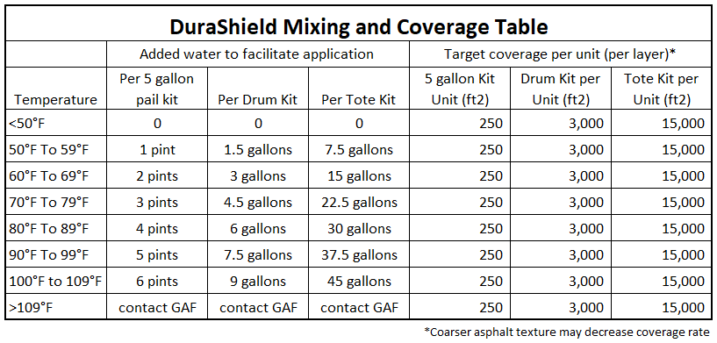

IMPORTANT NOTE: Adding water is to ease application in warmer conditions and does not change the area covered by a unit. Added water should not be included when estimating coverage rates.

3.4 COATING COVERAGE & THICKNESS
Coating coverage and average thickness is as outlined in TABLE 4 below. Actual coverage may be affected by the texture and porosity of the asphalt pavement substrate. A minimum of one coat is applied and two coats may be required in heavy traffic areas as designated in the Coatings Plan. The maximum single layer application rate is 65 ft2/gallon for a dry film thickness of 14 mils. Applicators may find that it is easier to achieve the desired aesthetic result by applying multiple layers at a lower coverage rate of 130 ft2/gallon for a dry film thickness of 7 mils. In either case, the minimum total dry film thickness must be 14 mils.

TABLE 4: Coating Coverage & Thickness
COVERAGE (approx.) |  | THICKNESS (approx.)
Application Rate |  | WET |  | DRY
sqft/gallon | sqm/liter* | mm | mil | mm | mil
65 | 1.6 | 0.64 | 25 | 0.36 | 14
130 | 3.2 | 0.32 | 13 | 0.18 | 7

3.5 RECOMMENDED COATING COVERAGE RATES
Check with the Pavement Coatings FSR for the territory in advance to confirm the recommended application for the climate conditions at the project location.

- Additional layers of coatings may be used to provide additional build thickness in high wear areas such as drive lanes and turning areas.
- A maintenance program may be required for applications exposed to:
- Abrasive materials (such as salt and sand)
- Abrasive equipment (such as snow removal equipment)
- Studded winter tires
- A Coating Plan describing the specific number of layers of coating required in each region of the project shall be included as part of the Submittal Package. The Coating Plan shall be considered as an Appendix to this specification and form part of the specification document.

3.6 OPENING TO TRAFFIC
Minimally, DURASHIELD coating must be 100% dry and sufficient curing time must be allowed before traffic is permitted on the surface.

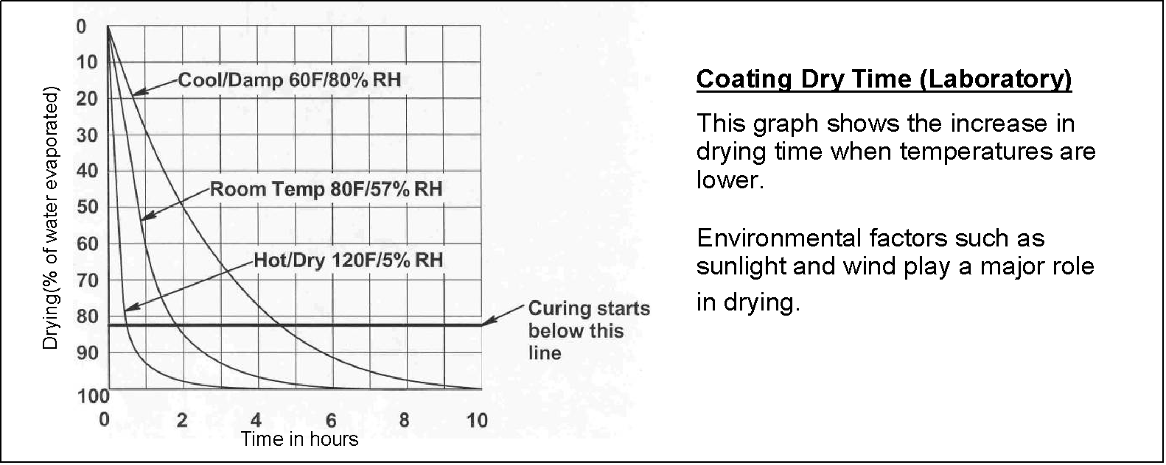
TABLE 5: COATING DRY TIMES (TYPICAL)

If DURASHIELD coatings are applied when moisture cannot evaporate, then the coating will not dry. The drying and curing of DURASHIELD has a direct impact on performance.

PART 4 – MEASUREMENT AND PAYMENT
4.1 MEASUREMENT
The measured area is the actual area of asphalt pavement where DURASHIELD has been applied, measured in place. No deduction will be made for the area(s) occupied by manholes, inlets, drainage structures, bollards or by any public utility appurtenances within the area.

4.2 PAYMENT
Payment will be full compensation for all work completed as per conditions set out in the contract. For unit price contracts, the payment shall be calculated using the measured area as determined above.

APPENDIX 1
Coating Plan

